Sponsor Name:

Contact Name:

Email Address:

Total Sponsorship Amount:
$
Title Sponsor  ($1500)  Safety Sponsor  ($1000) | Food & Drink ($500)  Gold Medal Sponsor  ($500) | Spirit of Fort Worth  Sponsor  ($1000)  Team ($125*)
Payment Method (check one):
Check Enclosed (payable to USS Fort Worth Support Committee)
Visa MasterCard Amex Discover

Cardholder Name:

Credit Card Number:

Expiration Date: | Security code:
Authorized Signature:
Please return your sponsorship form and payment to:
Hannah Bell
USS Fort Worth Support Committee
PO Box 246
Fort Worth, TX 76101
Hannah@ussfortworth.org 661-917-0343
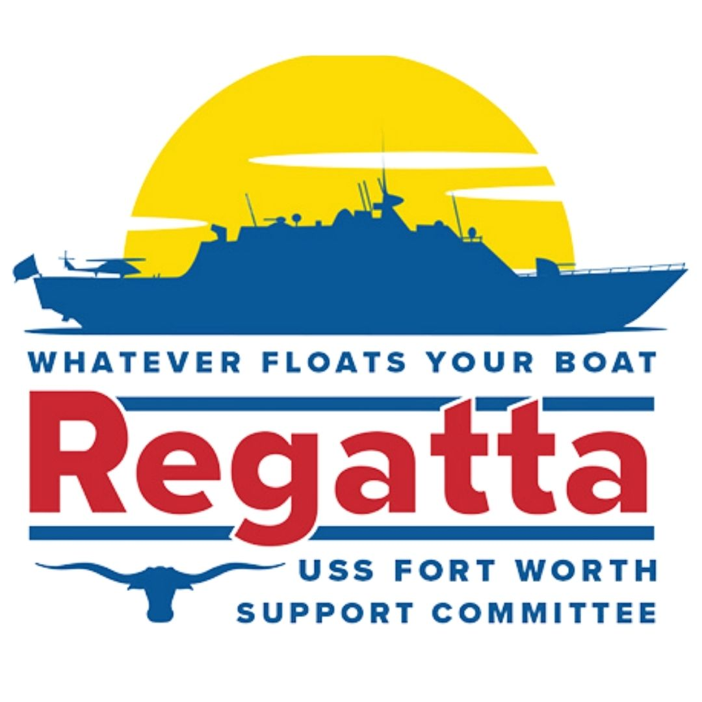
Team Member 1:

Team Member 2:

Team Member 3:

Team Member 4:

Team Member 5:

Boat/Team Name:

